**TC010 - JSON with invalid date format**

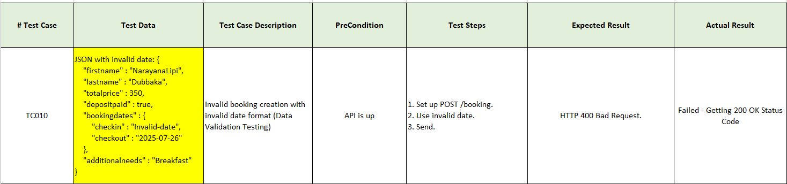

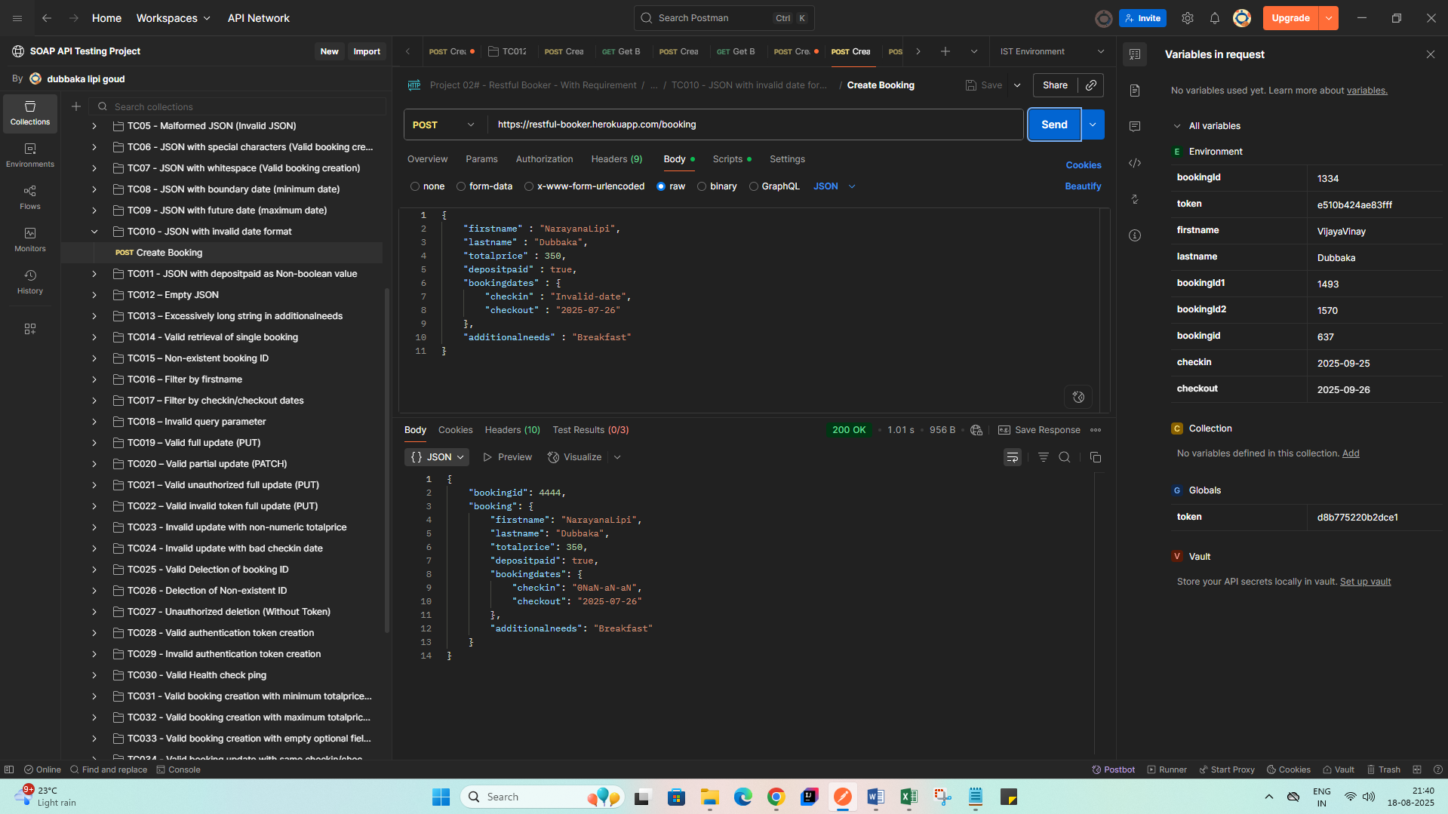

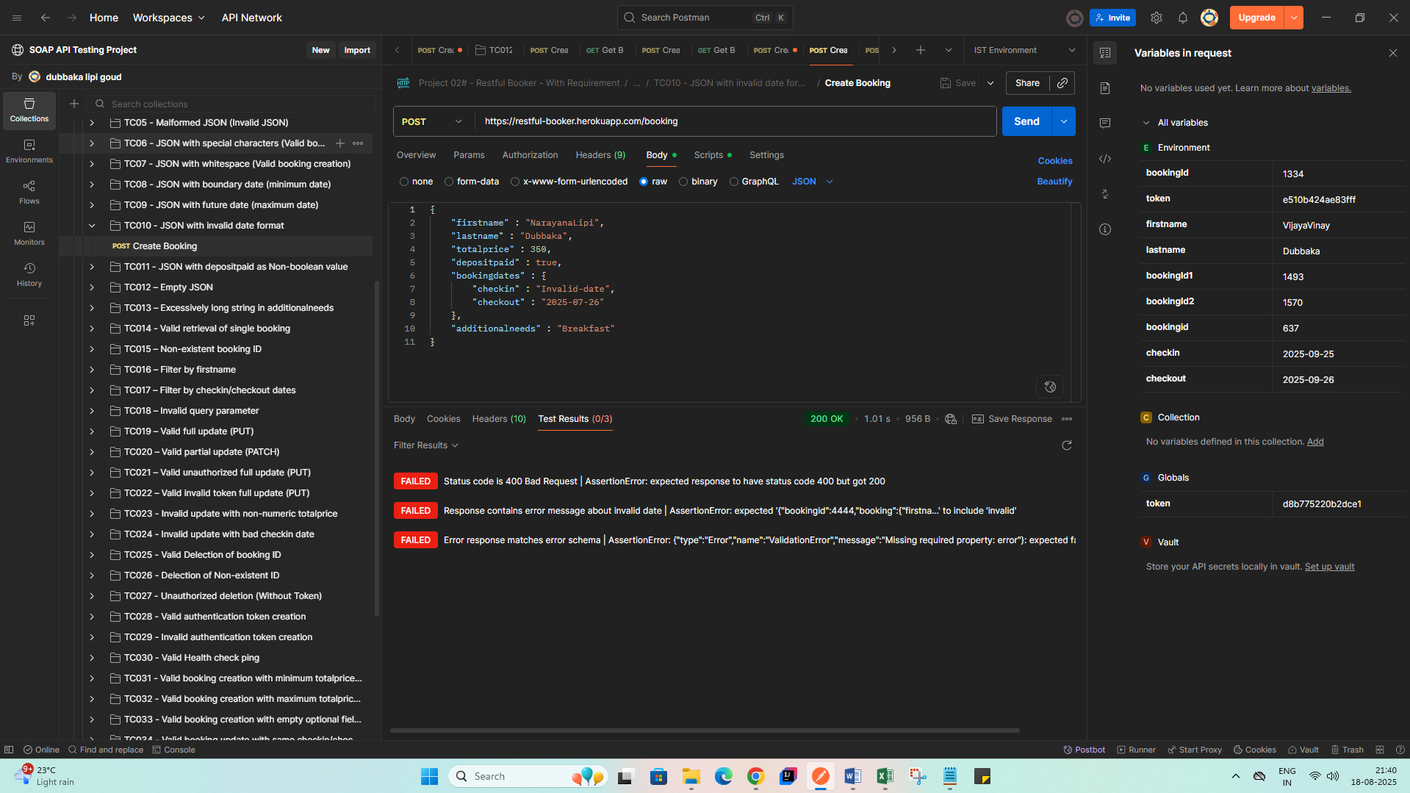

**Expected** – 400 Bad Request  
**Actual Results** – 200 OK